**Table 1**.Scale for quality assessment

|  |  |
| --- | --- |
| Criteria | Score |
| 1.Gout-type described |  |
| described | 1 |
| no described | 0 |
| 2.Quality control of genotyping methods |  |
| DNA sequencing | 2 |
| Taqman, HRM and so on | 1 |
| RFLP | 0 |
| 3.Habits and customs or pathogenic factors described |  |
| both described | 2 |
| only one described | 1 |
| no described | 0 |
| 4.Source of control |  |
| Population based | 2 |
| Hospital based | 1 |
| no described | 0 |
| 5.Case size |  |
| >=200 | 2 |
| 200>and>=100 | 1 |
| <100 | 0 |
| 6.Hard-Weinberg equilibrium(HWE) in control |  |
| yes | 1 |
| no | 0 |

When more than one genotyping method used in one study, we scored for the highest quality method.

146 Potentially relevant articles

99 Full text article analyze

18 Evaluated articles in detail

6 Articles meet the require

7 Articles included in meta-analysis

meta-analysis

**Figure 1**. Literature search and study selection

146 articles were found by primary relevant selection, and were selected through selected process.

**Table 2**. Applicable conditions for genetic model

|  |  |  |
| --- | --- | --- |
| Applicable conditions | | Genetic  Model |
| OR | P |
| OR1=OR3≠1  and OR2 = 1 | POR1 and POR3<0.05, POR2>0.05 | recessive model |
| OR1=OR2≠1  and OR3 =1 | POR1 and POR2<0.05, POR3>0.05 | dominant model |
| OR2= 1/OR3≠1  and OR1=1 | POR2 and POR3<0.05, POR1>0.05 | overdominant model |
| OR1>OR2>1  and OR1>OR3>1 | POR1, POR2 and POR3<0.05 | codominant model |

OR is abbreviation for odds ratio

OR1 (TT versus GG); OR2 (GT versus GG); OR3 (TT versus GT)

**Table 3** Characteristics of studies employed in meta-analysis

|  |  |  |  |  |  |  |  |  |  |  |  |  |
| --- | --- | --- | --- | --- | --- | --- | --- | --- | --- | --- | --- | --- |
| Study | Year | Country  of study | Continent | Ethnicity | HWE | Case/  control | Male/female Ratio  Case control | | Mean age  Case control | | MAF  Case control | |
| Woodward(white) | 2009 | USA | North America | Caucasian | No | 455/  8034 | - | - | - | - | 0.152 | 0.103 |
| Stark | 2009 | Germany | Europe | Caucasian | Yes | 677/  1552 | 2.37 | 1.26 | 58.3 | 58.5 | 0.137 | 0.104 |
| Matsuo | 2009 | Japan | Asia | Mongoloid | Yes | 159/  865 | All male | All male | - | - | 0.469 | 0.281 |
| Phipps-Green  (Maori) | 2010 | New zealand | Oceania | polynesian | Yes | 178/  212 | 2.79 | 0.48 | 39 | 40.8 | 0.107 | 0.097 |
| Phipps-Green  (Eastern Polynesia) | 2010 | - | Oceania | polynesian | Yes | 201/  210 | 2.86 | 0.50 | - | - | 0.107 | 0.090 |
| Phipps-Green  (Western Polynesia) | 2010 | - | Oceania | polynesian | Yes | 129/  71 | - | - | - | - | 0.519 | 0.275 |
| Phipps-Green (Caucasian) | 2010 | New zealand | - | Caucasian | Yes | 211/  558 | 6.25 | 0.69 | 46.2 | 44.6 | 0.242 | 0.126 |
| Phipps-Green  (Pacific Island) | 2010 | New zealand | Oceania | polynesian | Yes | 173/  109 | 22.3 | 1.18 | 33.5 | 37.7 | 0.439 | 0.202 |
| Yamagishi | 2010 | Japan | Asia | Mongoloid | No | 45/  3878 | 4.60 | 0.63 | - | - | 0.467 | 0.311 |
| Li | 2011 | China | Asia | Mongoloid | Yes | 200/  235 | All male | All male | 56.0 | 42.3 | 0.453 | 0.323 |
| Guan | Unpub | China | Asia | Mongoloid | Yes | 201/  200 | 11.56 | 0.70 | 58 | 51 | 0.54 | 0.30 |

Unpu means this study have not published before.

MAF is abbreviation for minor allele frequency.

**Table 4** Identified genetic model in subgroup.

|  |  |  |  |  |  |  |  |  |  |  |  |  |
| --- | --- | --- | --- | --- | --- | --- | --- | --- | --- | --- | --- | --- |
|  | | | OR1 | | | OR2 | | | OR3 | | | Suggest model |
|  | condition | subjects | OR | 95%CI | P | OR | 95%CI | P | OR | 95%CI | P |  |
| **Overall** | 11 | 4.30 | 3.069-6.037 | 0.00 | 1.70 | 1.405-2.059 | 0.00 | 2.36 | 1.707-3.250 | 0.00 | codominant |
| Year | **2009** | 3 | 2.81 | 1.765-4.484 | 0.00 | 1.82 | 1.252-2.652 | 0.00 | 1.34 | 0.942-1.920 | 0.10 | dominant |
| **2010** | 6 | 5.78 | 3.672-9.084 | 0.00 | 1.70 | 1.233-2.350 | 0.00 | 3.13 | 1.997-4.907 | 0.00 | codominant |
| **2011-** | 2 | 5.29 | 2.488-11.230 | 0.00 | 1.50 | 1.103-2.036 | 0.01 | 3.47 | 2.187-5.521 | 0.00 |
| HWE | **Yes** | 9 | 4.83 | 3.290-7.087 | 0.00 | 1.76 | 1.377-2.241 | 0.00 | 2.48 | 1.673-3.675 | 0.00 |
| **No** | 2 | 2.89 | 1.725-4.859 | 0.00 | 1.55 | 1.259-1.908 | 0.00 | 2.04 | 1.031-4.022 | 0.04 |
| Continent | **Non-Asian** | 7 | 4.15 | 2.222-7.759 | 0.00 | 1.63 | 1.322-2.015 | 0.00 | 2.10 | 1.422-3.107 | 0.00 |
| **Asian** | 4 | 4.56 | 3.235-6.429 | 0.00 | 1.80 | 1.172-2.778 | 0.01 | 2.54 | 1.442-4.479 | 0.00 |
| Number | **>1000** | 4 | 3.07 | 2.141-4.397 | 0.00 | 1.74 | 1.255-2.408 | 0.00 | 1.58 | 1.104-2.256 | 0.01 |
| **<1000** | 7 | 5.95 | 4.067-8.694 | 0.00 | 1.68 | 1.294-2.178 | 0.00 | 3.39 | 2.406-4.775 | 0.00 |
| Ethnicity | **Caucasian** | 3 | 2.80 | 1.513-5.182 | 0.00 | 1.61 | 1.308-1.975 | 0.00 | 1.66 | 1.042-2.648 | 0.03 |
| **Mongoloid** | 4 | 4.56 | 3.235-6.429 | 0.00 | 1.80 | 1.172-2.778 | 0.01 | 2.54 | 1.442-4.479 | 0.00 |
| **Polynesian** | 4 | 8.20 | 4.008-16.791 | 0.00 | 1.67 | 1.030-2.704 | 0.04 | 3.66 | 1.791-7.498 | 0.00 |
| Quality | **Low** | 4 | 3.83 | 1.927-7.617 | 0.00 | 1.56 | 1.206-2.011 | 0.00 | 2.25 | 1.420-3.555 | 0.00 |
| **High** | 7 | 4.59 | 3.052-6.894 | 0.00 | 1.78 | 1.353-2.332 | 0.00 | 2.40 | 1.534-3.750 | 0.00 |
| Gender | **Male** | 6 | 4.02 | 2.948-5.477 | 0.00 | 1.84 | 1.351-2.509 | 0.00 | 2.06 | 1.274-3.329 | 0.00 |
| **Female** | 4 | 4.20 | 1.981-8.918 | 0.00 | 1.26 | 0.805-1.962 | 0.31 | 4.17 | 1.118-15.579 | 0.03 | recessive |
| **Overall** | 10 | 4.04 | 3.032-5.384 | 0.00 | 1.68 | 1.286-2.182 | 0.00 | 2.34 | 1.467-3.746 | 0.00 | codominant |
| Age | **>46** | 5 | 4.20 | 3.153-5.598 | 0.00 | 1.69 | 1.218-2.349 | 0.00 | 2.29 | 1.392-3.780 | 0.00 |
| **<46** | 3 | 7.33 | 3.768-14.266 | 0.00 | 1.81 | 1.114-2.940 | 0.02 | 3.16 | 1.597-6.239 | 0.00 |
| **Overall** | 8 | 4.66 | 3.583-6.054 | 0.00 | 1.74 | 1.348-2.234 | 0.00 | 2.45 | 1.668-3.612 | 0.00 |

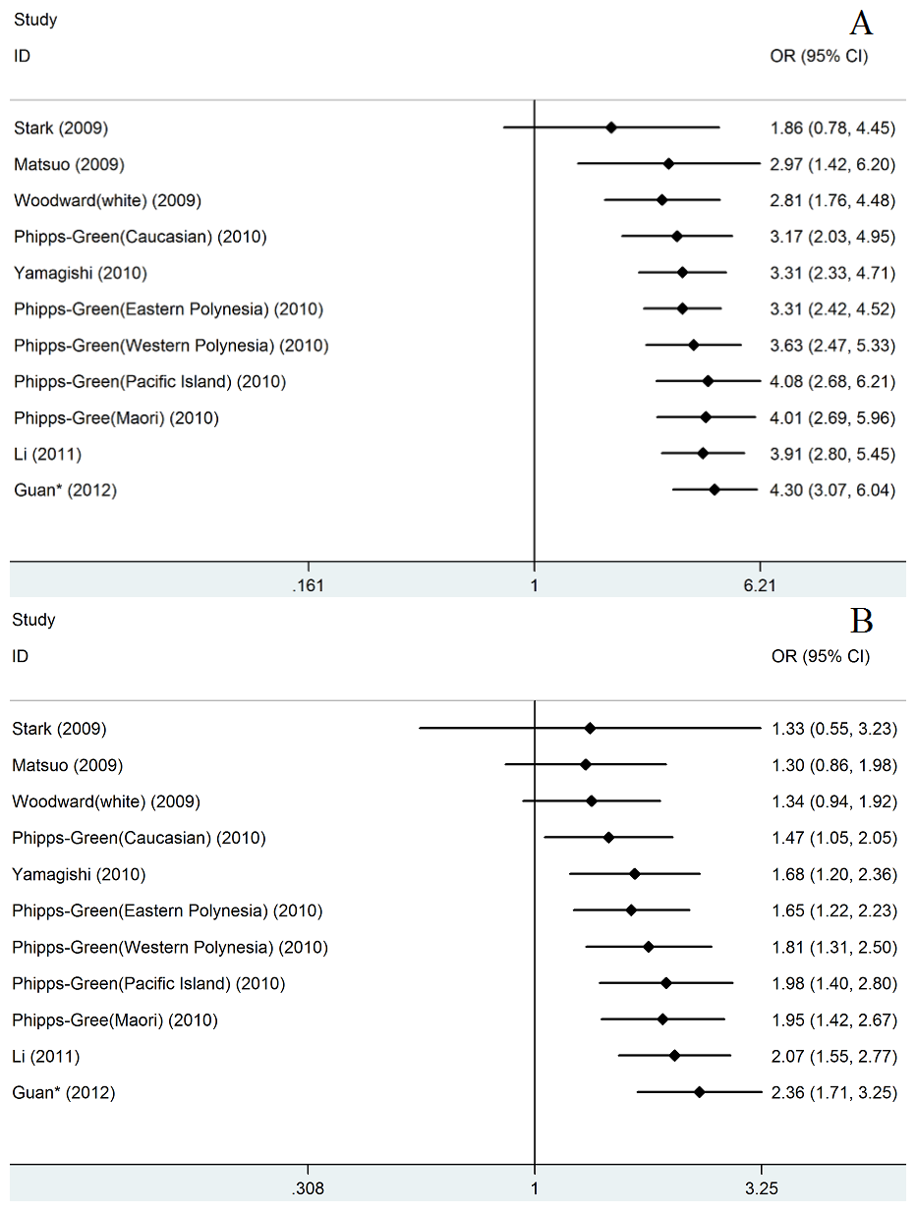

**Figure 2**. Cumulative meta-analysis of associations between the SNP rs2231142 and gout sorted primarily by published year. (A) in codominant model (TT versus GG); (B) in codominant model (TT versus GT).

We default the Guan’s study published in 2012 in cumulative meta-analysis.

**Figure 3**. Percents of rs2231142 T allele and genotypes change in different years.

**Table 5**.The result of meta-regression analysis in codominant model

|  |  |  |  |  |  |  |  |  |  |  |
| --- | --- | --- | --- | --- | --- | --- | --- | --- | --- | --- |
|  | LogOR | t | P>|t| | [95% Conf. Interval] | | I2 | ^I2 | Tau2 | ^Tau2 | R2 |
| TT versus  GG | Sex | -0.44 | 0.67 | -1.20057 | 0.8143707 | 0 | 5.13% | 0 | 0 | 0% |
| **Year\*** | 1.97 | **0.08** | -0.040956 | 0.6035375 | 40.50% | 21.51% | 0.1182 | 0.05429 | 59.01% |
| HWE | 1.24 | 0.245 | -0.405668 | 1.397079 | 40.50% | 35.62% | 0.1182 | 0.1111 | 16.13% |
| Continent | 0.33 | 0.752 | -0.720659 | 0.9627413 | 40.50% | 44.50% | 0.1182 | 0.1675 | -26.51% |
| Age* | -1.33 | 0.231 | -0.08072 | 0.0237599 | 34.40% | 29.72% | 0.0819 | 0.07339 | 7.96% |
| Quality | 0.49 | 0.633 | -0.6935492 | 1.081059 | 40.50% | 43.36% | 0.1182 | 0.1562 | -17.95% |
| Quality* | 0.07 | 0.943 | -0.3841871 | 0.4097663 | 40.50% | 45.93% | 0.1182 | 0.1804 | -36.23% |
| Number* | -2.12 | 0.063 | -0.000234 | 7.69E-06 | 40.50% | 18.33% | 0.1182 | 0.04515 | 65.91% |
| Ethnicity& |  |  |  |  | 43.26% |  | 0.13 | 0.0299 | 77% |
| TT versus  GT | Sex | -0.92 | 0.386 | -2.035447 | 0.876886 | 51.90% | 53.33% | 0.2512 | 0.2143 | -8.91% |
| **Year\*** | 3.49 | **0.007** | 0.1361756 | 0.6397529 | 37.90% | 0.00% | 0.1014 | 0 | 100.00% |
| HWE | 0.46 | 0.656 | -0.767962 | 1.161357 | 37.90% | 43.31% | 0.1014 | 0.149 | -20.32% |
| Continent | 0.34 | 0.744 | -0.690765 | 0.9322637 | 37.90% | 43.56% | 0.1014 | 0.1477 | -19.32% |
| Age* | -1.32 | 0.235 | -0.084776 | 0.0253756 | 48.10% | 35.79% | 0.1365 | 0.1042 | 25.74% |
| Quality | 0.05 | 0.959 | -0.8548063 | 0.8957059 | 37.90% | 44.11% | 0.1014 | 0.1508 | -21.75% |
| Quality* | -0.65 | 0.529 | -0.4705011 | 0.2592886 | 37.90% | 38.46% | 0.1014 | 0.1384 | -11.77% |
| Number* | -1.22 | 0.254 | -0.000225 | 0.0000674 | 37.90% | 35.00% | 0.1014 | 0.1196 | 3.43% |
| Ethnicity& |  |  |  |  | 42.71% |  | 0.12 | 0.1180 | 1.67% |
| GT versus  GG | Sex | 1.25 | 0.246 | -0.32009 | 1.08196 | 58.30% | 56.41% | 0.0892 | 0.07485 | 9.15% |
| Year* | -0.43 | 0.679 | -0.33186 | 0.22622 | 60.40% | 64.39% | 0.0567 | 0.08147 | -21.29% |
| HWE | 0.57 | 0.582 | -0.47411 | 0.794375 | 60.40% | 63.82% | 0.0567 | 0.08001 | -19.12% |
| Continent | 0.43 | 0.675 | -0.42415 | 0.625464 | 60.40% | 61.70% | 0.0567 | 0.07543 | -12.30% |
| Age* | 0.07 | 0.944 | -0.03719 | 0.039474 | 67.00% | 71.64% | 0.0833 | 0.1079 | -24.47% |
| Quality | 0.53 | 0.607 | -0.401802 | 0.649492 | 60.40% | 63.71% | 0.0567 | .07686 | -14.43% |
| Quality* | 1.12 | 0.291 | -0.1145065 | 0.3400154 | 60.40% | 60.94% | 0.0567 | .06363 | 5.27% |
| Number* | -0.49 | 0.634 | -0.00011 | 7.27E-05 | 60.40% | 63.43% | 0.0567 | 0.08197 | -22.04% |
| Ethnicity& |  |  |  |  | 64.43% |  | 0.07 | 0.0944 | -34.86% |

* means those factors were treated as Continuous variables.

^ means the results analyzed by meta-regression analysis.

& means R software was used for meta-regression analysis.

In the meta-regression analysis of published year, we default the Guan’s study published in 2012.

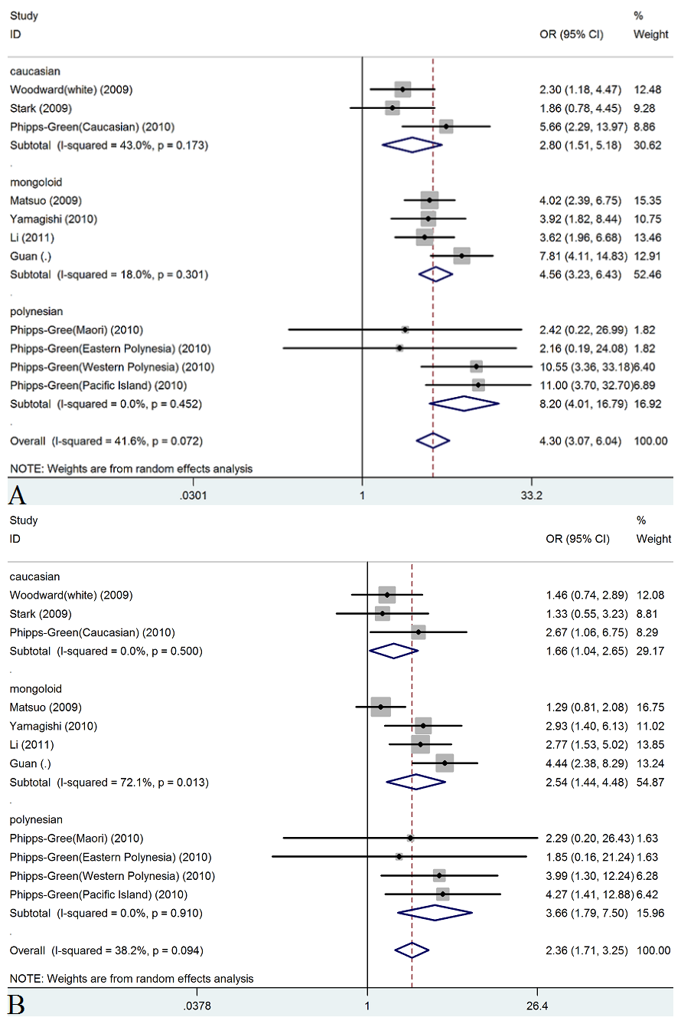

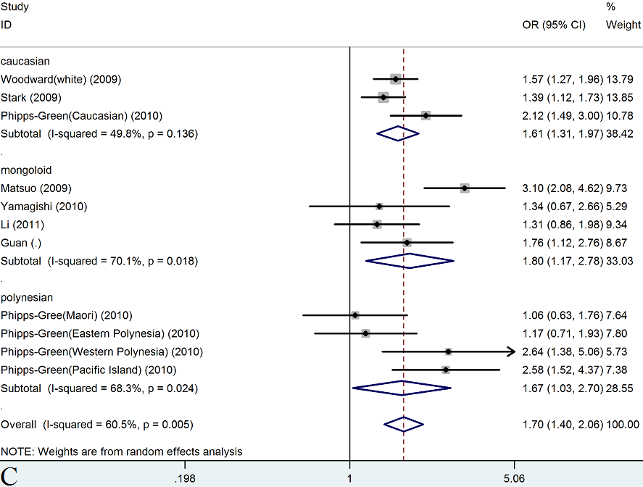

**Figure 4**. Forest plots for rs2231142 with gout in codominant model in different ethnicities.

(A) in codominant model (TT versus GG) (B) in codominant model (TT versus GT) ; (C) in codominant model (GT versus GG).

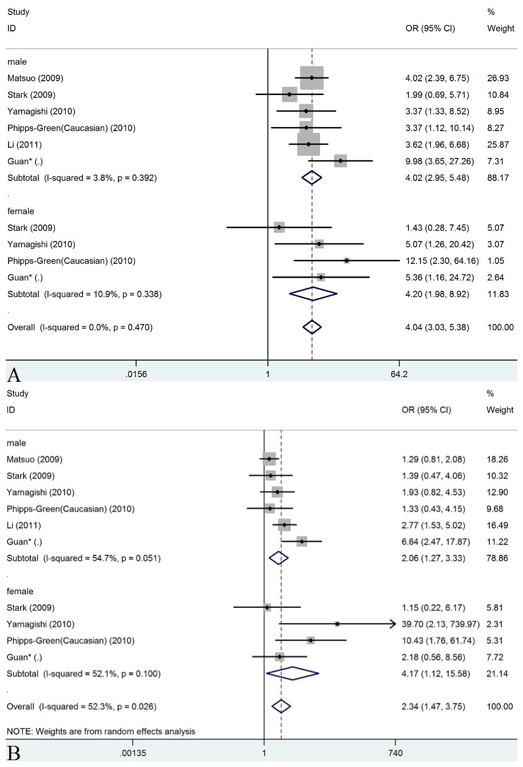

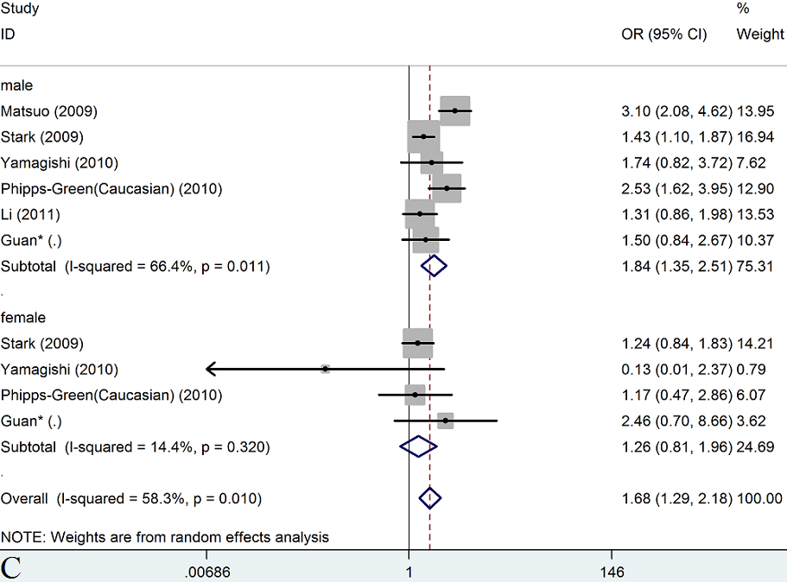

**Figure 5**. Forest plots for rs2231142 with gout in codominant model in different gender.

(A) in codominant model (TT versus GG) (B) in codominant model (TT versus GT) ; (C) in codominant model (GT versus GG).

**Figure 6**. Percents of rs2231142 T allele, genotypes and gout prevalence change in different populations.

S.Table 1. Characteristics of studies employed in meta-analysis

|  |  |  |  |  |  |  |  |  |  |  |  |  |  |
| --- | --- | --- | --- | --- | --- | --- | --- | --- | --- | --- | --- | --- | --- |
| Study | Year | Control source | Quality score | Genotyping method | Gout type | Other describe | TT | GT | GG | TTC | GTC | GGC | Ref |
| Woodward(white) | 2009 | Pb | 5 | TaqMan | - | N | 10 | 118 | 327 | 86 | 1483 | 6465 | 8 |
| Stark | 2009 | Hb | 7 | TaqMan | - | Y | 9 | 168 | 500 | 12 | 299 | 1241 | 32 |
| Matsuo | 2009 | Pb | 8 | Sequencing and Taqman/ HRM | primary | Y | 31 | 87 | 41 | 87 | 316 | 462 | 1 |
| Phipps-Green  (Maori) | 2010 | Pb | 6 | TaqMan | - | Y | 2 | 34 | 142 | 1 | 39 | 172 | 17 |
| Phipps-Green  (Eastern Polynesia) | 2010 | Pb | 5 | TaqMan | - | N | 2 | 39 | 160 | 1 | 36 | 173 | 17 |
| Phipps-Green  (Western Polynesia) | 2010 | Pb | 5 | TaqMan | - | N | 34 | 66 | 29 | 4 | 31 | 36 | 17 |
| Phipps-Green (Caucasian) | 2010 | Pb | 7 | TaqMan | - | Y | 13 | 76 | 122 | 8 | 125 | 425 | 17 |
| Phipps-Green  (Pacific Island) | 2010 | Pb | 6 | TaqMan | - | Y | 37 | 78 | 58 | 4 | 36 | 69 | 17 |
| Yamagishi | 2010 | Pb | 5 | energy transfer probe method | - | Y | 12 | 18 | 15 | 377 | 1655 | 1846 | 33 |
| Li | 2011 | Hb | 7 | SNapshot | primary | Y | 45 | 91 | 64 | 20 | 112 | 103 | 34 |
| Guan | Unpub | Hb | 7 | HRM and sequencing | - | Y | 67 | 82 | 52 | 16 | 87 | 97 | - |

Other describes included habits, customs and pathogenic factors.

Pb: Population based. Hb: Hospital based.

S.Table 2 Meta-analysis for rs2231142 associated with gout in other genetic models

|  |  |  |  |  |  |  |  |  |  |  |  |  |  |  |
| --- | --- | --- | --- | --- | --- | --- | --- | --- | --- | --- | --- | --- | --- | --- |
|  |  |  | Dominant model | | | | Recessive model& | | | | Overdominant model | | | |
|  | condition | subjects | OR | 95%CI | P | P* | OR | 95%CI | P | P* | OR | 95%CI | P | P* |
| Overall# |  | 11 | 1.98 | 1.581-2.486 | 0.00 | 0.00 | 3.36 | 2.706-4.180 | 0.00 | 0.14 | 0.74 | 0.625-0.888 | 0.00 | 0.01 |
| Case/Control | <0.5 | 5 | 1.96 | 1.458-2.624 | 0.00 | 0.00 | 2.44 | 1.833-3.256 | 0.00 | 0.43 | 0.63 | 0.516-0.778 | 0.00 | 0.06 |
| >0.5and<1 | 3 | 1.35 | 1.038-1.754 | 0.03 | 0.37 | 3.02 | 1.765-5.165 | 0.00 | 0.93 | 0.99 | 0.762-1.281 | 0.93 | 0.75 |
| >1 | 3 | 3.09 | 2.320-4.111 | 0.00 | 0.69 | 6.09 | 3.820-9.720 | 0.00 | 0.94 | 0.82 | 0.551-1.209 | 0.31 | 0.14 |
| HWE | yes | 9 | 2.07 | 1.551-2.750 | 0.00 | 0.00 | 3.53 | 2.763-4.518 | 0.00 | 0.11 | 0.74 | 0.602-0.918 | 0.01 | 0.01 |
| no | 2 | 1.63 | 1.336-1.995 | 0.00 | 0.72 | 2.61 | 1.641-4.164 | 0.00 | 0.31 | 0.79 | 0.471-1.321 | 0.37 | 0.09 |
| Continent | non-asian | 7 | 1.82 | 1.385-2.388 | 0.00 | 0.00 | 3.49 | 2.427-5.026 | 0.00 | 0.23 | 0.68 | 0.600-0.767 | 0.00 | 0.43 |
| asian | 4 | 2.33 | 1.656-3.272 | 0.00 | 0.07 | 3.29 | 2.508-4.315 | 0.00 | 0.08 | 0.88 | 0.552-1.406 | 0.60 | 0.00 |
| Number | >1000 | 4 | 1.87 | 1.332-2.640 | 0.00 | 0.00 | 2.25 | 1.656-3.058 | 0.00 | 0.60 | 0.66 | 0.527-0.838 | 0.00 | 0.07 |
| <1000 | 7 | 2.06 | 1.493-2.832 | 0.00 | 0.00 | 4.64 | 3.351-6.426 | 0.00 | 0.68 | 0.81 | 0.628-1.044 | 0.10 | 0.04 |
| Ethnicity | caucasian | 3 | 1.69 | 1.319-2.171 | 0.00 | 0.05 | 2.45 | 1.569-3.819 | 0.00 | 0.27 | 0.65 | 0.546-0.764 | 0.00 | 0.25 |
| mongoloid | 4 | 2.33 | 1.656-3.272 | 0.00 | 0.07 | 3.29 | 2.508-4.315 | 0.00 | 0.08 | 0.88 | 0.552-1.406 | 0.60 | 0.00 |
| polynesian | 4 | 1.97 | 1.050-3.700 | 0.04 | 0.00 | 5.72 | 2.886-11.346 | 0.00 | 0.72 | 0.78 | 0.600-1.009 | 0.06 | 0.61 |
| Quality | low | 4 | 1.79 | 1.241-2.569 | 0.00 | 0.06 | 3.23 | 2.128-4.895 | 0.00 | 0.38 | 0.74 | 0.593-0.913 | 0.01 | 0.32 |
| high | 7 | 2.09 | 1.527-2.855 | 0.00 | 0.00 | 3.41 | 2.642-4.393 | 0.00 | 0.07 | 0.73 | 0.569-0.944 | 0.02 | 0.00 |
| Gender | male | 6 | 2.14 | 1.582-2.888 | 0.00 | 0.01 | 2.92 | 2.214-3.852 | 0.00 | 0.22 | 0.73 | 0.518-1.030 | 0.07 | 0.00 |
| female | 4 | 1.36 | 0.989-1.879 | 0.06 | 0.51 | 4.07 | 1.986-8.329 | 0.00 | 0.19 | 0.88 | 0.550-1.411 | 0.60 | 0.28 |
| overall | 10 | 1.93 | 1.499-2.477 | 0.00 | 0.01 | 3.02 | 2.332-3.919 | 0.00 | 0.15 | 0.77 | 0.585-1.011 | 0.06 | 0.00 |
| Age | >46 | 5 | 2.52 | 1.354-4.696 | 0.00 | 0.00 | 3.10 | 2.398-4.017 | 0.00 | 0.08 | 0.83 | 0.604-1.148 | 0.26 | 0.00 |
| <46 | 3 | 2.07 | 1.150-3.720 | 0.02 | 0.01 | 5.44 | 2.805-10.552 | 0.00 | 0.65 | 0.64 | 0.448-0.921 | 0.02 | 0.14 |
| overall | 8 | 2.34 | 1.536-3.567 | 0.00 | 0.00 | 3.40 | 2.680-4.323 | 0.00 | 0.11 | 0.76 | 0.597-0.969 | 0.03 | 0.00 |

& mean all meta-analysis in recessive model used fixed-effects model.

#means the pool result for all 11 subjects after meta-analysis.

* means P-value for heterogeneity.

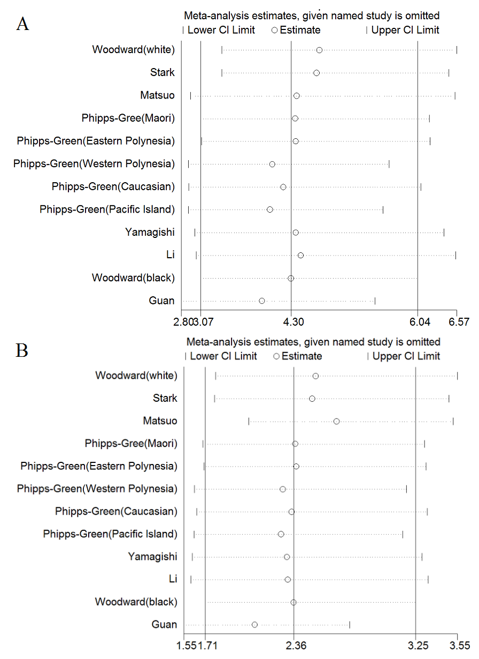

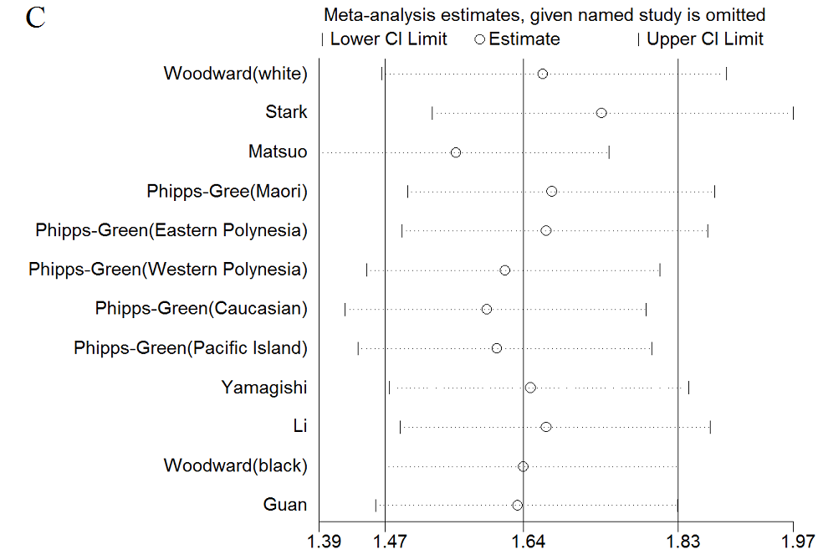

S.Figure 1. Influence analysis of the summary odds ratio coefficients on the association for rs2231142 with gout (A)in codominant model (TT versus GG) (B)in codominant model (TT versus GT) ; (C) in codominant model (GT versus GG).